Chapter 11, Solution 68.

Let 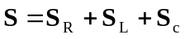
where 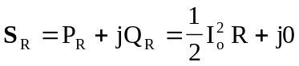
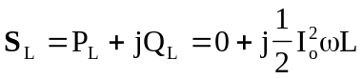
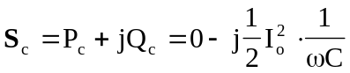

Hence,
